**Diving into Kubernetes-1: Creating and Testing a Horizontal Pod Autoscaling (HPA) in Kubernetes Cluster**

Let’s think, we have a constantly running production service with a load that is variable in time, where it is very busy during the day, and relatively low at night. Normally, we would want the number of nodes in the cluster and the number of pods in deployment to dynamically adjust to the load to meet end-user demand. *The****Cluster Autoscaling (CA)*** feature together with the ***Horizontal Pod Autoscaler (HPA)***can handle this for you automatically. We will discuss them in detail in the articles by doing and testing them practically and step by step.

In this article, we will learn Kubernetes Autoscaling, I will explain the working logic of Horizontal Pod Autoscaler and Metric Server. We will do HPA in the Kubernetes Cluster consisting of a MangoDB Database, a Nodejs web application, and a PHP-Apache application. We will test whether our HPA is working by connecting to the K8s cluster. And we will see how the autoscaler reacts to increased load. For this, we will start a container, and send an infinite loop of queries to the php-apache service. In a different terminal in order to constantly check the output of the cluster via the “watch” command. We will do them practically and step by step.



Gif 1 - Test of HPA’s running.

**Topics we will cover:**

1. [What is a Horizontal Pod Autoscaling in Kubernetes Cluster](https://cmakkaya.medium.com/kubernetes-creating-and-testing-a-horizontal-pod-autoscaling-hpa-in-kubernetes-cluster-548f2378f0c3#5e23)  
2. [How does a HorizontalPodAutoscaler Work?](https://cmakkaya.medium.com/kubernetes-creating-and-testing-a-horizontal-pod-autoscaling-hpa-in-kubernetes-cluster-548f2378f0c3#6f8c)  
3. [Running and Exposing the Php-Apache Server](https://cmakkaya.medium.com/kubernetes-creating-and-testing-a-horizontal-pod-autoscaling-hpa-in-kubernetes-cluster-548f2378f0c3#11d6)  
4. [Creating the HorizontalPodAutoscaler](https://cmakkaya.medium.com/kubernetes-creating-and-testing-a-horizontal-pod-autoscaling-hpa-in-kubernetes-cluster-548f2378f0c3#ff68)  
5. [Installing Metric Server to The Cluster](https://cmakkaya.medium.com/kubernetes-creating-and-testing-a-horizontal-pod-autoscaling-hpa-in-kubernetes-cluster-548f2378f0c3#f2a2)  
6. [Increasing Load to Test the HPA by Using The Infinite Loop of Queries](https://cmakkaya.medium.com/kubernetes-creating-and-testing-a-horizontal-pod-autoscaling-hpa-in-kubernetes-cluster-548f2378f0c3#6320)  
7. [Stopping Dummy Load](https://cmakkaya.medium.com/kubernetes-creating-and-testing-a-horizontal-pod-autoscaling-hpa-in-kubernetes-cluster-548f2378f0c3#3e9d)  
8. [As a result](https://cmakkaya.medium.com/kubernetes-creating-and-testing-a-horizontal-pod-autoscaling-hpa-in-kubernetes-cluster-548f2378f0c3#ff6d)

**1. What is a Horizontal Pod Autoscaling in Kubernetes Cluster**

Let’s think, we have a constantly running production service with a load that is variable in time, where it is very busy during the day, and relatively low at night. Normally, we would want the number of nodes in the cluster and the number of pods in deployment to dynamically adjust to the load to meet end-user demand. *The****Cluster Autoscaling*** feature together with the ***Horizontal Pod Autoscaler*** can handle this for you automatically.

Cluster Autoscaler (CA) adjusts the number of nodes in the cluster when pods fail to schedule or when nodes are underutilized. We will discuss CA in detail in the next article **“Kubernetes: Setting up and Testing a *Cluster Autoscaling (CA)*in Kubernetes Cluster”**. Horizontal Pod Autoscaler (HPA), in short, adjusts the number of replicas of an application. (1)

In Kubernetes, a **HorizontalPodAutoscaler** automatically updates a workload resource (such as a [Deployment](https://kubernetes.io/docs/concepts/workloads/controllers/deployment/) or [Stateful Set](https://kubernetes.io/docs/concepts/workloads/controllers/statefulset/)), with the aim of automatically scaling the workload to match demand. If I give an example from AWS, HorizontalPodAutoscaler works like AWS Autoscaling.

Horizontal scaling means that the response to increased load is to deploy more [Pods](https://kubernetes.io/docs/concepts/workloads/pods/). This is different from *vertical* scaling, which for Kubernetes would mean assigning more resources (for example: memory or CPU) to the Pods that are already running for the workload.

If the load decreases, and the number of Pods is above the configured minimum, the HorizontalPodAutoscaler instructs the workload resource (the Deployment, Stateful Set, or other similar resource) to scale back down. (2)

**2. How does a HorizontalPodAutoscaler Work?**

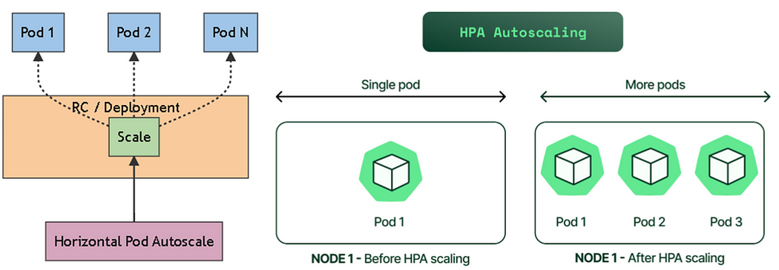

Figure 1

HorizontalPodAutoscaler controls the scale of a Deployment and its ReplicaSet, as shown in Figure 1.

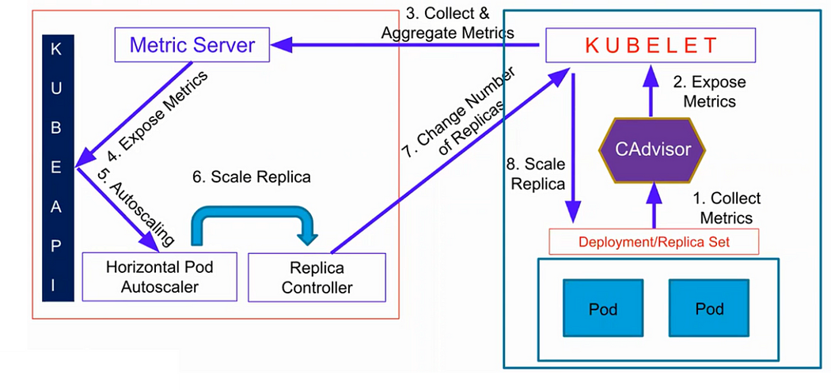Figure 2 (3)

For per-pod resource metrics (like CPU), the controller fetches the metrics from the resource metrics API for each Pod targeted by the HorizontalPodAutoscaler. Then, if a target utilization value is set, the controller calculates the utilization value as a percentage of the equivalent [resource request](https://kubernetes.io/docs/concepts/configuration/manage-resources-containers/#requests-and-limits) on the containers in each Pod. If a target raw value is set, the raw metric values are used directly. The controller then takes the mean of the utilization or the raw value (depending on the type of target specified) across all targeted Pods, and produces a ratio used to scale the number of desired replicas, as shown in Figure 2. (4)

**3. Running and Exposing the Php-Apache Server**

To demonstrate a HorizontalPodAutoscaler, you will first start the second application Deployment that runs a container using the hpa-example image, and expose it as a [Service](https://kubernetes.io/docs/concepts/services-networking/service/) using the following manifest, and as shown in Figure 3.

apiVersion: apps/v1  
kind: Deployment  
metadata:  
 name: php-apache  
spec:  
 selector:  
 matchLabels:  
 run: php-apache  
 replicas: 1  
 template:  
 metadata:  
 labels:  
 run: php-apache  
 spec:  
 containers:  
 - name: php-apache  
 image: k8s.gcr.io/hpa-example  
 ports:  
 - containerPort: 80  
 resources:  
 limits:  
 memory: 500Mi  
 cpu: 100m  
 requests:  
 memory: 250Mi  
 cpu: 80m  
---  
apiVersion: v1  
kind: Service  
metadata:  
 name: php-apache-service  
 labels:  
 run: php-apache  
spec:  
 ports:  
 - port: 80  
 nodePort: 30002  
 selector:  
 run: php-apache   
 type: NodePort

In order to do so, run the following command, as shown in Figure 4.

kubectl apply -f php-apache.yaml

Get the pods and services.

kubectl get po  
kubectl get svc

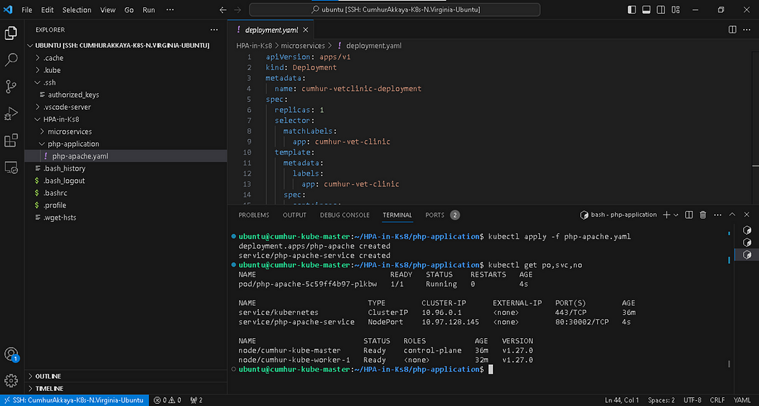

Figure 3

Check what the PHP web app presents us, as shown in Figure 4.

On opening browser “http://<public-node-ip>:<node-port>” we see

OK!

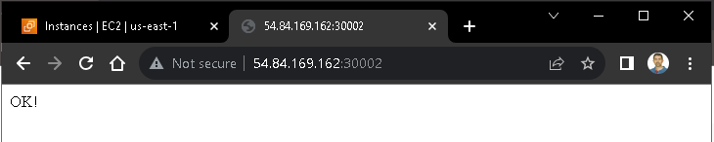

Figure 4

Alternatively, you can use; curl <public-worker node-ip>:<node-port>, as shown in Figure 5.

OK!

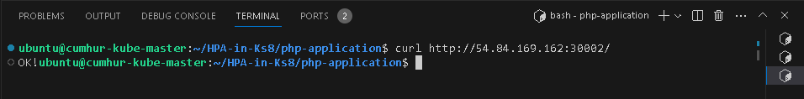

Figure 5

**Note:**Do not forget to open the “Port <node-port>” in the security group of your node instance.

**4. Creating the HorizontalPodAutoscaler**

The following command will create a Horizontal Pod Autoscaler that maintains between 2 and 10 replicas of the Pods controlled by the php-apache deployment we created in the third step of these instructions. Roughly speaking, HPA will increase and decrease the number of replicas (via the deployment) to maintain an average CPU utilization across all Pods of 50% (since each pod requests 200 milli-cores by kubectl run), this means average CPU usage of 100 milli-cores). See [the link](https://kubernetes.io/docs/tasks/run-application/horizontal-pod-autoscale/#algorithm-details) for more details on the algorithm. (5)

In order to activate the **HPA**, enter the following command, as shown in Figure 6.

kubectl autoscale deployment php-apache --cpu-percent=50 --min=2 --max=10

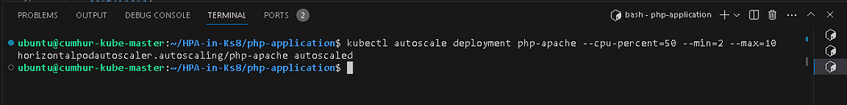

Figure 6

OR

We can also use the following “yaml files”;

$ pwd  
/home/ubuntu/microservices  
$ mkdir auto-scaling && cd auto-scaling  
$ cat << EOF > hpa-php-apache.yaml  
  
apiVersion: autoscaling/v1  
kind: HorizontalPodAutoscaler  
metadata:  
 name: php-apache  
spec:  
 scaleTargetRef:  
 apiVersion: apps/v1  
 kind: Deployment  
 name: php-apache  
 minReplicas: 2  
 maxReplicas: 10  
 targetCPUUtilizationPercentage: 50  
  
EOF  
```

Run autoscale deployment yaml files,

$ kubectl apply -f hpa-php-apache.yaml

You can check the current status of the newly-made HorizontalPodAutoscaler, by running the following command, as shown in Figure 7.

# You can use "hpa" or "horizontalpodautoscaler"; either name works OK.  
kubectl get hpa

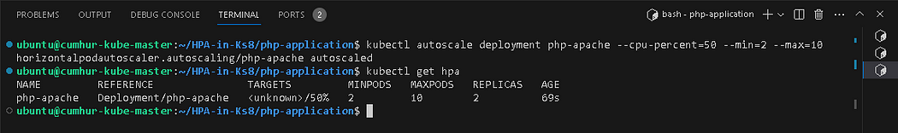

Figure 7

Use the following watch command to constantly monitor the current status, as shown in Figure 8.

$ watch -n3 kubectl get service,hpa,pod -o wide

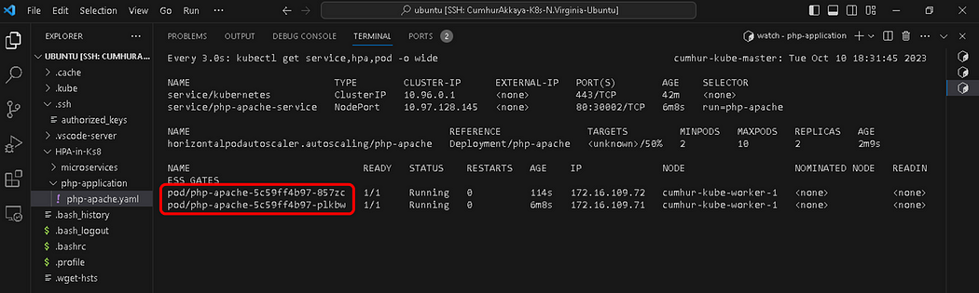

Figure 8

The php-apache Pod number is 2, the minimum number.

**Attention:** The HPA line under “TARGETS” shows “<unknown>/50%” . The “unknown” means the HPA can’t identify the current use of the CPU, as shown in Figure 9.

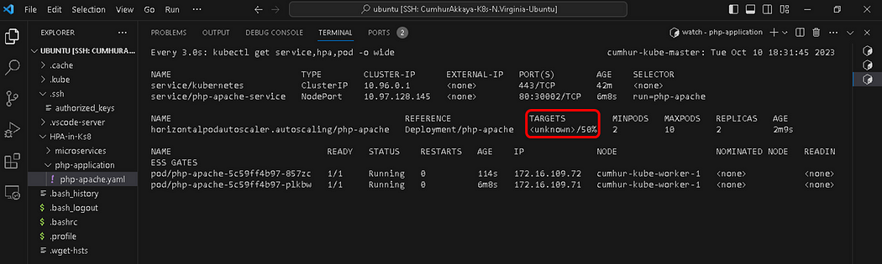

Figure 9

We will check again the current status of autoscaler by running the following command, as shown in Figure 10.

kubectl get hpa  
kubectl describe hpa

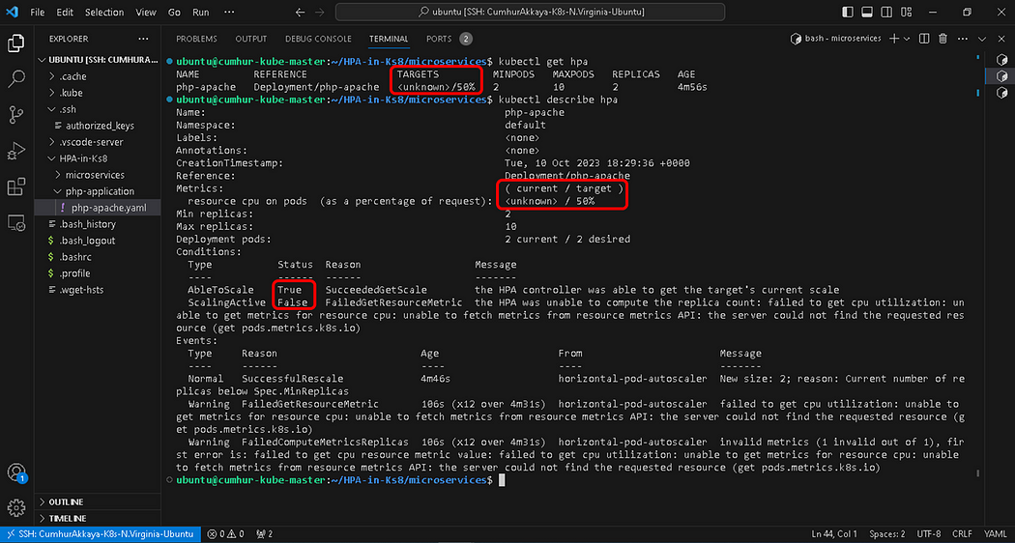

Figure 10

**The “metrics” can’t be calculated**. So, the “metrics server” should be uploaded to the cluster.

**5. Installing Metric Server to The Cluster.**

First Delete the existing Metric Server if any, as shown in Figure 11.

$ kubectl delete -n kube-system deployments.apps metrics-server

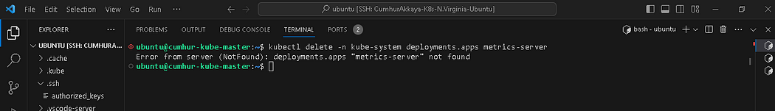

Figure 11

Install the Metric Server from [GitHub](https://github.com/kubernetes-sigs/metrics-server/releases/tag/v0.5.0) with the following command, as shown in Figure 12. (6) (7)

$ wget https://github.com/kubernetes-sigs/metrics-server/releases/download/v0.5.0/components.yaml

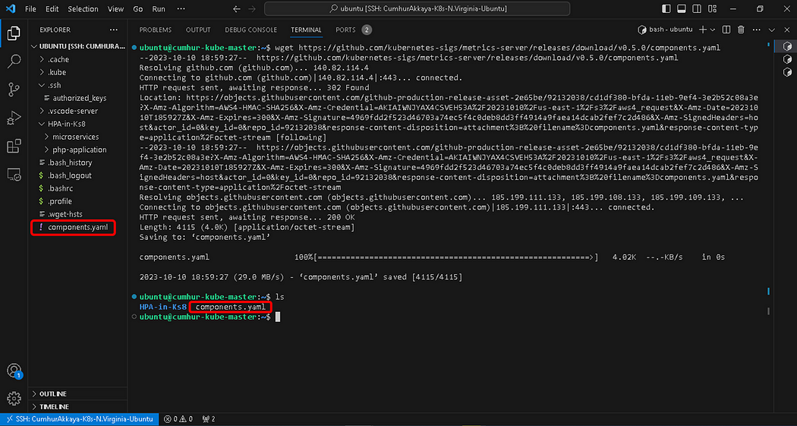

Figure 12

To ensure secure communication, we need to make the following edits to the “components.yaml” file. For this, select the “Deployment” part in the file. Add the below line to the“containers.args field under the deployment object”, as shown in Figure 13.

- --kubelet-insecure-tls

After making the correction, it should look like the following:

apiVersion: apps/v1  
kind: Deployment  
......  
 containers:  
 - args:  
 - --cert-dir=/tmp  
 - --secure-port=443  
 - --kubelet-insecure-tls  
 - --kubelet-preferred-address-types=InternalIP,ExternalIP,Hostname  
 - --kubelet-use-node-status-port  
 - --metric-resolution=15s  
......

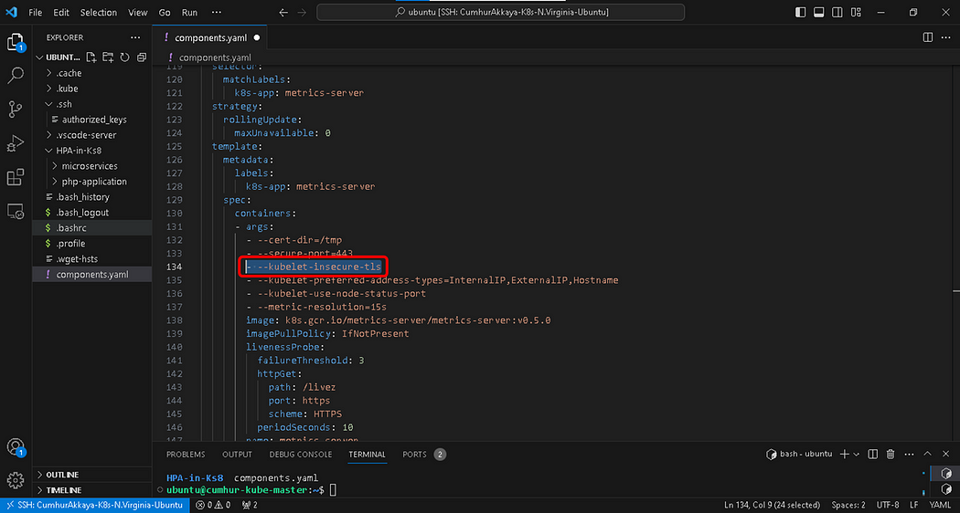

Figure 13

Add “metrics-server” to your Kubernetes instance, as shown in Figure 14.

$ kubectl apply -f components.yaml

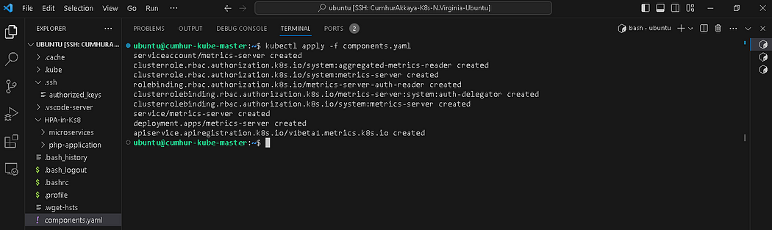

Figure 14

Wait 1–2 minutes or so.

Verify the existence of “metrics-server” run by the below command, as shown in Figure 15.

$ kubectl -n kube-system get pods

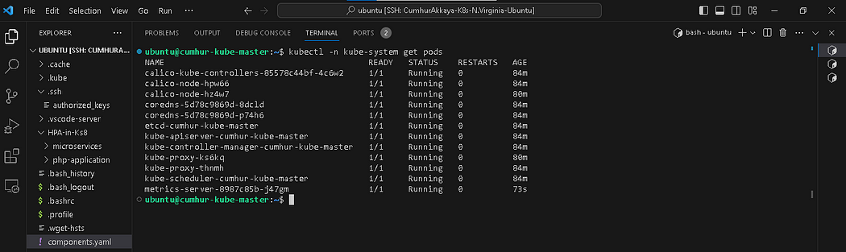

Figure 15

Verify “metrics-server” can access the resources of the pods and nodes, as shown in Figure 16.

kubectl top pods  
kubectl top nodes

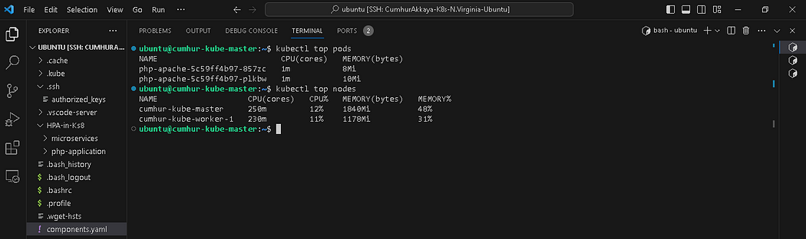

Figure 16

In the values under “TARGETS”, the values are changed from “<unknown>/50%” to “1%/50%” & “2%/50%”, which means the HPA can now identify the current use of the CPU, as shown in Figure 17.

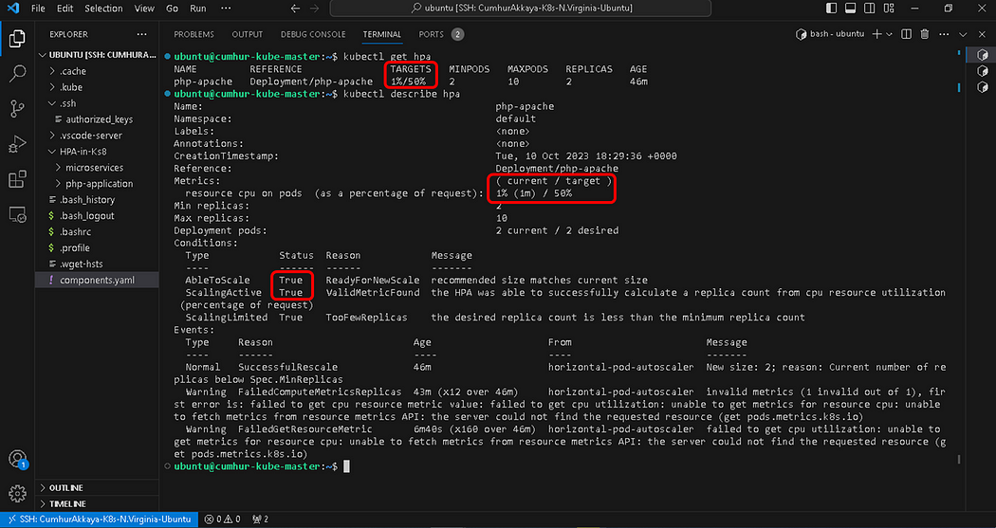

Figure 17

Note: If it is still “<unknown>/50%” , check the “spec.template.spec.containers.resources.request” field of deployment.yaml files. It is required to define this field. Otherwise, the autoscaler will not take any action for that metric.

For per-pod resource metrics (like CPU), the controller fetches the metrics from the resource metrics API for each Pod targeted by the HorizontalPodAutoscaler. Then, if a target utilization value is set, the controller calculates the utilization value as a percentage of the equivalent resource request on the containers in each Pod.

Please note that if some of the Pod’s containers do not have the relevant resource request set, CPU utilization for the Pod will not be defined and the autoscaler will not take any action for that metric.

**6. Increasing Load to Test the HPA by Using The Infinite Loop of Queries**



Gif 1 — Test of HPA’s running.

We want to see how the autoscaler reacts to increased load. For this, we will start a container, and send an infinite loop of queries to the php-apache service. We must run the command below in a different terminal in order to constantly check output, as shown in Figure 18.

$ kubectl run -it --rm load-generator --image=busybox /bin/sh

Paste the following code into the terminal by changing the “IP” and “port number”.

while true; do wget -q -O- http://<puplic ip>:<port number of php-apache-service>; done

Hit enter for the command prompt, The word “OK! OK! OK! OK!…” will start to appear. Our load (the infinite loop of queries) started to run, as shown in Figure 18.

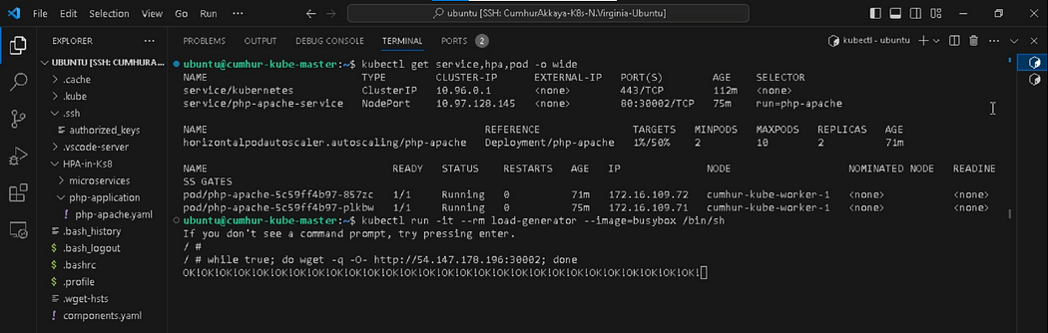

Figure 18

Open a new terminal and check the HPA. The HPA automatically created a pod because the load increased, as shown in Figure 19.

$ kubectl get hpa

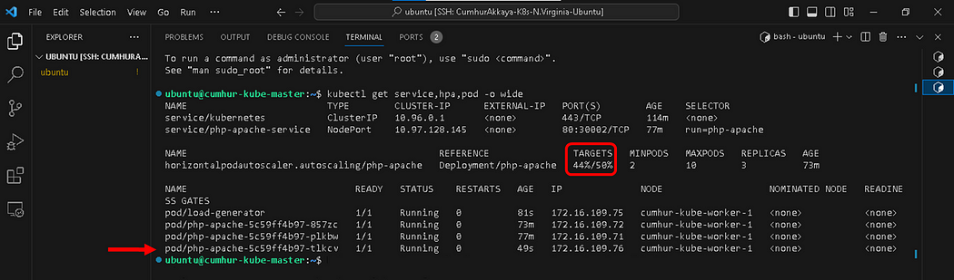

Figure 19

On the watch board, we must run the command below in a different terminal in order to constantly check output, as shown in Figure 20.

$ watch -n3 kubectl get service,hpa,pod -o wide

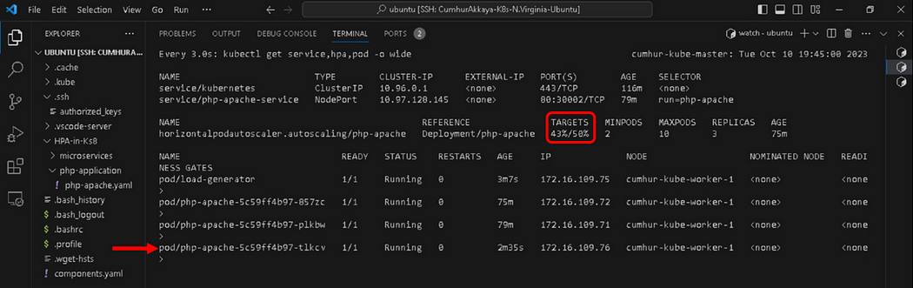

Figure 20

When the load continues to increase, HPA automatically creates second a pod, as shown in Figure 21.

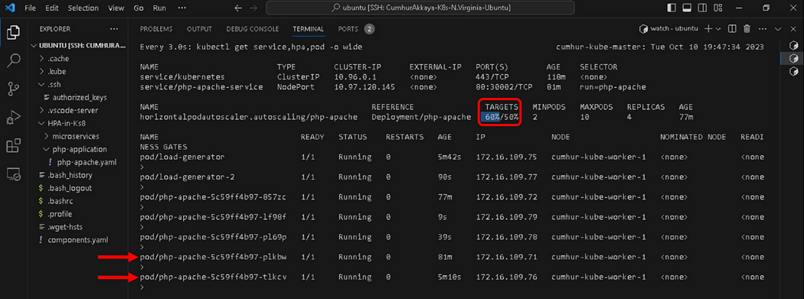

Figure 21

**7. Stopping load**

We will finish our example by stopping the user load.

In the terminal where we created the container with busybox image, terminate the load generation by typing “Ctrl + C”, and then “exit”. Close the load-introducing terminals gracefully and observe the behavior at the watch board, as shown in Figure 22.

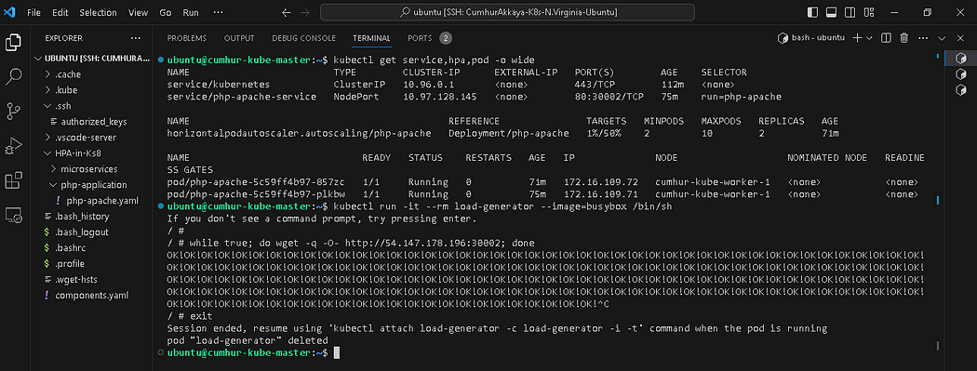

Figure 22

Then we will verify the result state (after a minute or so), It’s back to normal status (minimal pod number:2), as shown in Figure 23.

$ kubectl get hpa  
$ kubectl get deployment

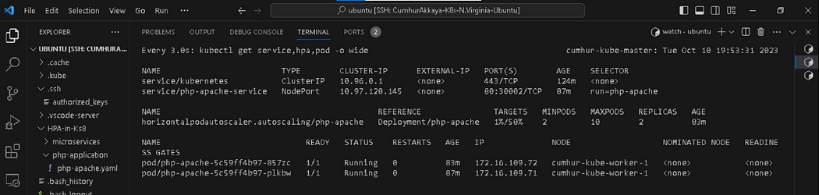

**8. As a result**

We learned Kubernetes Autoscaling and the working logic of Horizontal Pod Autoscaler and Metric Server. We set up an HPA in the Kubernetes Cluster consisting of a PHP-Apache application. We tested whether our HPA was working by connecting to the K8s cluster. And we saw how the autoscaler reacts to increased load. In a different terminal constantly checked the output of the cluster via the “watch” command.